Product Specification
Name: Line touch dimmer
Model: DM200
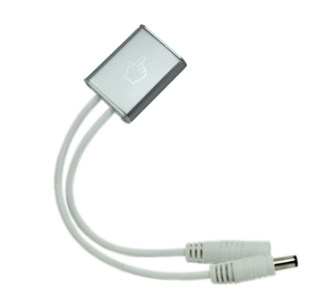
Summarization
Led line touch dimmer adopts capacitive touch technology, ON/OFF and Dimming function can achieve touch, direct current 12/24V directly drive led lighting product,such as led cabinet light, led dome light, LED light bar and led panel light, it can also be used as on/off button, to realize one key switch control of lamps, at the same time, in the process of dimming, light and shade change evenly, soft, no flicker.
Technical parameters
Working temperature: -20-60℃
Power supply voltage: DC 12-24V
Output voltage: DC 12-24V
Output: 1 channel
External dimension: L39*W30.8*H9.0 mm
Packing size: L174*w84mm
Net weight: 26.0g
Gross weight: 38.0g
Max output current: 6A
Max output power: 72W/12V 144W/24V

External dimension
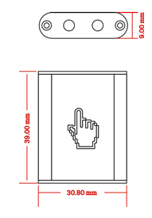
Direction for use
- When power on, it is OFF. Short touch the hand icon, the dimmer turns OFF to ON, short touch the icon again, the dimmer turns ON to OFF.
- Long press the hand icon:
A. If in OFF, begin to Cyclic dimming from the maximum brightness.
B. If in ON, begin to Cyclic dimming from the current brightness.
3.Midway of dimmer when long press hand icon:
Release your hand when long press and dimming, then brightness stops at the current
state, long press and dimming again, the dimming will go on in the opposite way.
Notice: Please not hold the dimmer in the hands when using it, it should be put on the desk or fixed on wall, otherwise, it will become ineffective.

Typical Application
